Fred's Coffee sells two blends of beans: Yusip Blend and Exotic Blend. Yusip Blend is one-half Costa Rican beans and one-half Ethiopian beans. Exotic Blend is one-quarter Costa Rican beans and three-quarters Ethiopian beans. Profit on the Yusip Blend is $3.50 per pound, while profit on the Exotic Blend is $4.00 per pound. Each day Fred receives a shipment of 200 pounds of Costa Rican beans and 330 pounds of Ethiopian beans to use for the two blends. How many pounds of each blend should be prepared each day to maximize profit? What is the maximum profit?   
  
let x = number of pounds of yusip blend.  
let y = number of pounds of exotic blend.   
  
profit equation is:  
profit = 3.5x + 4y   
  
set up a table as follows:

costa rican ethiopean

yusip blend .5 .5

exotic blend .25 .75

your constraint equations are:  
x >= 0  
y >= 0  
.5x + .25y <= 200  
.5x + .75y <= 330   
  
to graph these equations, solve for y in those equations that have y in them to get;  
x >= 0  
y >= 0  
y <= (200 - .5x) / .25  
y <= (330 - .5x) / .75   
  
x = 0 is the same line as the y-axis.  
y = 0 is the same line as the x-axis.   
  
your graph is shown below:  
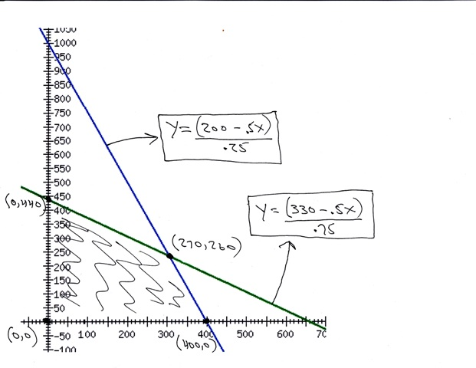   
  
the shaded area is the area of on the graph that meets all the constraints.  
this is called the region of feasibility.   
  
your maximum / minimum solution will be at the intersection of the lines that bound this region of feasibility.   
  
the intersection points are:  
(0,0)  
(0,440)  
(270,260)  
(400,0)   
  
your profit equation is:  
profit = 3.5x + 4.0y  
profit is calculated at each intersection point as follows:

intersection point profit

(0,0) 3.5\*0 + 4.0\*0 = 0

(0,440) 3.5\*0 + 4.0\*440 = 1750

(270,260) 3.5\*270 + 4.0\*260 = 1985 \*\*\*\*\*

(400,0) 3.5\*400 + 4.0\*0 = 1400

your maximum profit is when you sell 270 pounds of yusip blend and 260 pounds of exotic blend.   
  
QUESTION NUMBER 3   
  
The Mapple store sells Mapple computers and printers. The computers are shipped in 12-cubic-foot  
boxes and printers in 8-cubic-foot boxes. The Mapple store estimates that at least 30 computers can be  
sold each month and that the number of computers sold will be at least 50% more than the number of  
printers. The computers cost the store $1000 each and are sold for a profit of $1000. The printers cost  
$300 each and are sold for a profit of $350. The store has a storeroom that can hold 1000 cubic feet and  
can spend $70,000 each month on computers and printers. How man computers and how many printers  
should be sold each month to maximize profit? What is the maximum profit?   
  
let x = number of computers.  
let y = number of printers.   
  
your profit equation is:  
profit = 1000x + 350y   
  
your constraint equations are:  
x >= 0  
y >= 0  
x >= 30 (minimum number of computers sold each month)  
x >= 1.5y (ratio of computers to printers)  
12x + 8y <= 1000 (storage available)  
1000x + 300y <= 70,000 (amount of money available to spend)   
  
in order to graph the constraint equations, you need to solve for y in those equations that have y in them and then graph the equality portion of each of these equations.   
  
x >= 0  
y >= 0  
x >= 30 (minimum number of computers sold each month)  
y <= x/1.5 (ratio of computers to printers)  
y <= (1000-12x)/8 (storage available)  
y <= (70,000-1000x)/300 (amount of money available to spend)   
  
x = 0 is a vertical line that is the same line as the y-axis.  
y = 0 is a horizontal line that is the same line as the x-axis.  
x = 30 is a vertical line at x = 30.   
  
your graph is shown below:  
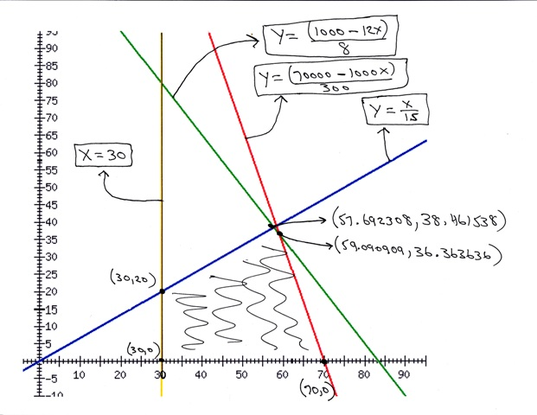  
your profit equation is:  
profit = 1000x + 350y  
profit is calculated at each intersection point as follows:

intersection point profit

(30,20) 37,000

(70,0) 70,000

(57.692308,38.461538) 71,153.8463

(59.090909,36.363636) 71,818.1816 \*\*\*\*\*

your maximum profit is when you sell 59.090909 computers and 36.363636 printers.  
since this is not possible, then you need to find the closest integers that will provide the maximum profit and still stay within the boundaries of the constraints.  
your possible integer combinations around the maximum profit point are:

profit storage cost meets requirements

(59,36) 71,600 996 69,800 yes

(59,37) 71,950 1004 70,100 exceeds storage and cost

(60,36) 72,600 1008 70,800 exceeds storage and cost

(60,37) 72,600 1016 71,100 exceeds storage and cost

your minimum cost integer solution occurs when 59 computers are sold and 36 printers are sold   
the ratio requirements are at least 1.5 computers for every printer.  
59/36 = 1.63888 exceeds that ratio requirements as well.   
  
QUESTION NUMBER 4   
  
The Appliance Barn has 2400 cubic feet of storage space for refrigerators. Large refrigerators come  
in 60-cubic-foot packing crates and small refrigerators come in 40-cubic-foot crates. Large refrigerators  
can be sold for a $250 profit and the smaller ones can be sold for $150 profit. How many of each type  
of refrigerator should be sold to maximize profit and what is the maximum profit if:  
a) At least 50 refrigerators must be sold each month.  
b) At least 40 refrigerators must be sold each month.  
c) There are no restrictions on what must be sold.   
  
let x = number of large refrigerators  
let y = number of small refrigerators   
  
your profit equation is:  
250x + 150y   
  
your constraint equations are:  
60x + 40y <= 2400 (storage)  
x + y >= 50 (part a minimum sold)  
x + y >= 40 (part b minimum sold)   
  
to graph these constraints, you need to solve for y in those equations that have y in them and then graph the equality portions of those equations.   
  
y <= (2400 - 60x) / 40 (storage)  
y >= 50 - x (part a minimum sold)  
y >= 40 - x (part b minimum sold)   
  
x = 0 is the vertical line that is the same line as the y-axis.  
y = 0 is the horizontal line that is the same line as the x-axis.   
  
the graph of your part a equation looks like this:  
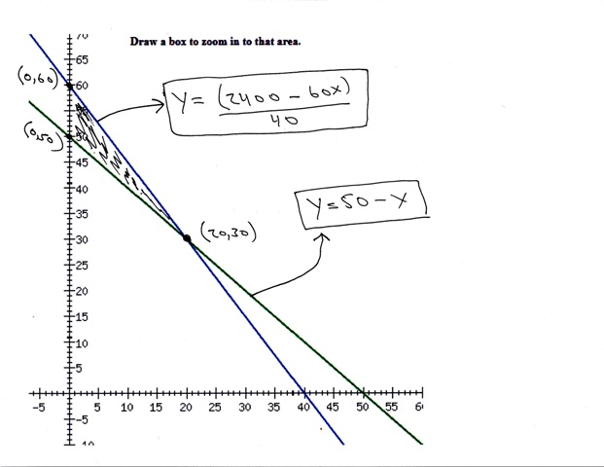  
the graph of your part b equations looks like this:  
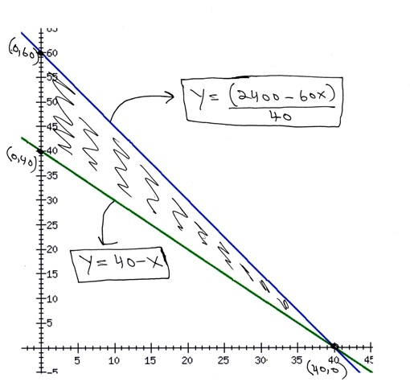  
the graph of your part c equations looks like this:  
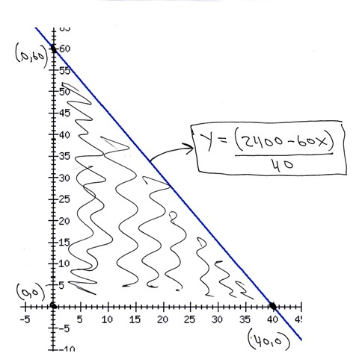  
your profit equation is:  
profit = 250x + 150y   
  
your maximum minimum solutions will be at the intersection points of the lines that are the boundaries of the area of feasibility.  
the area of feasibility is the area on the graph that meets all the constraints.   
  
profit is calculated at each intersection point as follows:

intersection point profit

part a:

(0,60) 9000

(0,50) 7500

(20,30) 9500 \*\*\*\*\*

part b:

(0,60) 9000

(0,40) 6000

(40,0) 10,000 \*\*\*\*\*

part c:

(0,0) 0

(0,60) 9000

(40,0) 10,000 \*\*\*\*\*

your maximum profit for part a is when you sell 20 large refrigerators and 30 small refrigerators for a total of 9500.  
your maximum profit for part b is when you sell 40 large refrigerators and 0 small refrigerators fo a total of 10,000.  
your maximum profit for part c is the same as for part b.   
  
QUESTION NUMBER 5   
  
Shannon's Chocolates produces semisweet chocolate chips and milk chocolate chips at its plants in  
Wichita, KS and Moore, OK. The Wichita plant produces 3000 pounds of semisweet chips and 2000  
pounds of milk chocolate chips each day at a cost of $1000, while the Moore plant produces 1000  
pounds of semisweet chips and 6000 pounds of milk chocolate chips each day at a cost of $1500.  
Shannon has an order from Food Box Supermarkets for at least 30,000 pounds of semisweet chips and  
60,000 pounds of milk chocolate chips. How should Shannon schedule its production so that it can fill  
the order at minimum cost? What is the minimum cost?   
  
let x = number of days of production at wichita plant.  
let y = number of days of production at moore plant.   
  
your cost equation is:  
cost = 1000x + 1500y   
  
make a table as follows:

semisweet milk

wichita 3000 2000

moore 1000 6000

your constraint equations are:  
x >= 0  
y >= 0  
3000x + 1000y >= 30,000  
2000x + 6000y >= 60,000   
  
to graph these equations, solve for y in those equations where y is present and then graph the equality portion of those equations.   
  
y = (30,000 - 3000x) / 1000  
y = (60,000 - 2000x) / 6000   
  
x = 0 is a vertical line that is the same line as the y-axis.  
y = 0 is a vertical line that is the same line as the x-axis.   
  
a graph of your equation looks like this:  
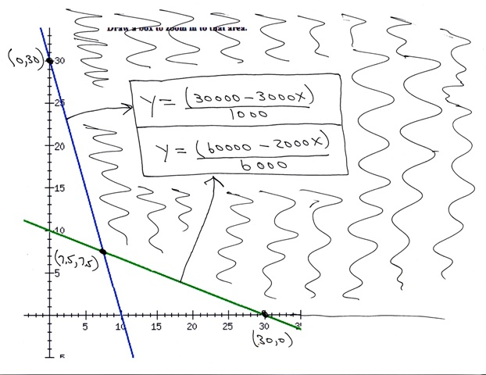  
your cost equation is:  
cost = 1000x + 1500y  
cost is calculated at each intersection point as follows:

intersection point cost

(0,30) 45,000

(30,0) 30,000

(7.5,7.5) 18,750 \*\*\*\*\*

your minimum cost is 18,750.  
this occurs when wichita plant takes 7.5 days and moore plant takes 7.5 days.